PIZZA SALES SQL QUERIES
A.KPI’S
1.Total Revenue
SELECT SUM(total_price) AS Total_Revenue FROM pizza_sales_csv_file;
OUTPUT:
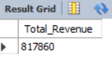
2.AVERAGE ORDER VALUE
SELECT
ROUND(SUM(total_price)/
COUNT(DISTINCT order_id),2) AS Average_order_value
FROM pizza_sales_csv_file;
OUTPUT:
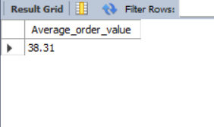

3.Total pizza sold
SELECT SUM(quantity) AS Totao_Pizzas_Sold FROM pizza_sales_csv_file;
OUTPUT:

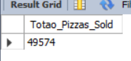

4. Total orders
SELECT COUNT(DISTINCT order_id) AS Total_Orders FROM pizza_sales_csv_file;
OUTPUT:

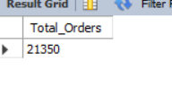

5. AVG Pizza Per Order
SELECT SUM(quantity)/COUNT(DISTINCT order_id) AS AVG_Pizza_Per_Order FROM pizza_sales_csv_file;
OUTPUT:

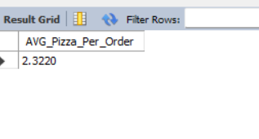
CHARTS REQUIREMENTS
1.DAILY TREND FOR TOTAL ORDERS
SELECT dayname(order_date) AS Week_day, COUNT(DISTINCT order_id) AS Total_Orders FROM pizza_sales_csv_file
GROUP BY Week_day
ORDER BY Total_Orders DESC;
OUTPUT:

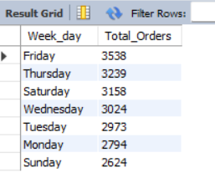

2.MONTHLY TREND FOR TOTAL ORDERS

SELECT MONTHNAME(order_date) AS Month_date, COUNT(DISTINCT order_id) AS Total_Orders FROM pizza_sales_csv_file
GROUP BY Month_date
ORDER BY Total_Orders DESC;
OUTPUT:
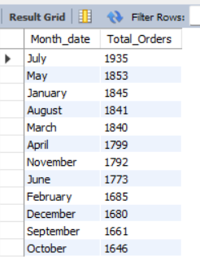

3. CATEGORY SALES PERCENTAGE

SELECT
pizza_category,
ROUND(SUM(total_price),2)AS category_sales,
ROUND(
SUM(total_price)/(SELECT SUM(total_price)
FROM pizza_sales_csv_file) * 100,
2
) AS Sales_Percentage
FROM pizza_sales_csv_file
GROUP BY pizza_category;
OUTPUT:
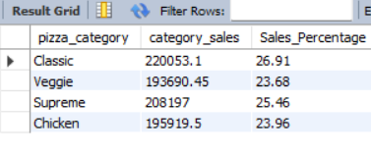

4. PIZZA SIZE SALES PERCENTAGE

SELECT pizza_size,ROUND(SUM(total_price)*100/
(SELECT SUM(total_price) FROM pizza_sales_csv_file),2)AS Percentage_Pizza_Size
FROM pizza_sales_csv_file
GROUP BY pizza_size
ORDER BY Percentage_Pizza_Size DESC;
OUTPUT:
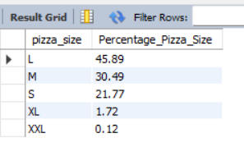

5. TOTAL PIZZA SOLD BY PIZZA CATEGORY
SELECT pizza_category,SUM(quantity)
FROM pizza_sales_csv_file
GROUP BY pizza_category;
OUTPUT:
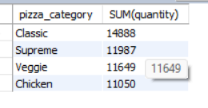

6. TOP 5 REVENUE BY PIZZA NAME
SELECT pizza_name,
ROUND(SUM(total_price),2)AS revenue
FROM pizza_sales_csv_file
GROUP BY pizza_name
ORDER BY revenue DESC LIMIT 5;
OUTPUT:
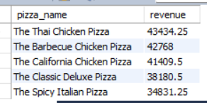

6. BOTTOM 5 REVENUE BY PIZZA NAME
SELECT pizza_name,
ROUND(SUM(total_price),2)AS revenue
FROM pizza_sales_csv_file
GROUP BY pizza_name
ORDER BY revenue ASC
LIMIT 5;
OUTPUT:
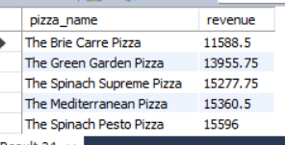

6. TOP 5TOTAL QTY BY PIZZA NAME
SELECT pizza_name,
SUM(quantity) AS Total_quantity
FROM pizza_sales_csv_file
GROUP BY pizza_name
ORDER BY Total_quantity DESC
LIMIT 5;
OUTPUT:
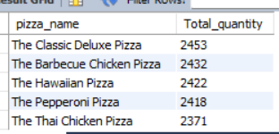
6.BOTTOM 5 TOTAL QTY BY PIZZA NAME
SELECT pizza_name,
SUM(quantity) AS Total_quantity
FROM pizza_sales_csv_file
GROUP BY pizza_name
ORDER BY Total_quantity ASC
LIMIT 5;
OUTPUT:
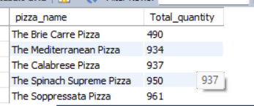

6. TOP 5 TOTAL ORDERS BY PIZZA NAME
SELECT pizza_name,
COUNT(DISTINCT order_id) AS Total_orders
FROM pizza_sales_csv_file
GROUP BY pizza_name
ORDER BY Total_orders DESC
LIMIT 5;
OUTPUT:
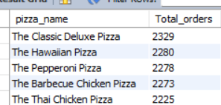

6. BOTTOM 5 TOTAL ORDERS BY PIZZA NAME

SELECT pizza_name,
COUNT(DISTINCT order_id) AS Total_orders
FROM pizza_sales_csv_file
GROUP BY pizza_name
ORDER BY Total_orders ASC
LIMIT 5;
OUTPUT:
